Welcome All, If you are walking from here to Ludham Village, it is not safe to walk along the main road.
The map below has been created to show you a safe pedestrian route from Ludham Bridge to Ludham Village.

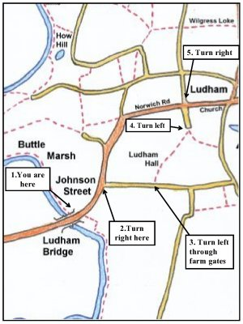
This red arrow route takes you on quiet lanes and public footpaths far from the busy traffic on the A1062.
DIRECTIONS (look out for the red arrows).
1. From Ludham Bridge walk along the main road passing the shops on your left. There is a good roadside footpath on the left hand side of the road.
2. Continue to a road junction just past the Dog Inn and turn right into a quiet lane (Hall Road).
3. Continue along the lane until you come to the entrance to Ludham Hall Farm on your left. Go through the farm gates and follow the footpath between the farm house on your left and barns on your right. Continue on the footpath between fields until you come to a junction of paths.
4. Take the left hand path which quickly curves right into Lovers Lane. Follow the lane with houses on your left until you come to a T junction.
5. Turn right at the T junction into Norwich Road which has a good roadside footpath on the right hand side. Follow this road into the middle of Ludham Village. You will know you are there when you see the church on your right and the pub (Kings Arms) on your left.
Enjoy your visit to Ludham.

